[ZANG] - [Chuanjie] - ITCAssignment

Student ID: 699382953

[chuanjiezang@gmail.com](mailto:chuanjiezang@gmail.com)

Q1:

Step 1: Pseudo-Code

Start

Output "Please enter an integer:"

Read the input integer

If integer % 2 == 0

Output "The number is even."

Otherwise.

Output "The number is odd."

End

Step 2: Java Code in Eclipse

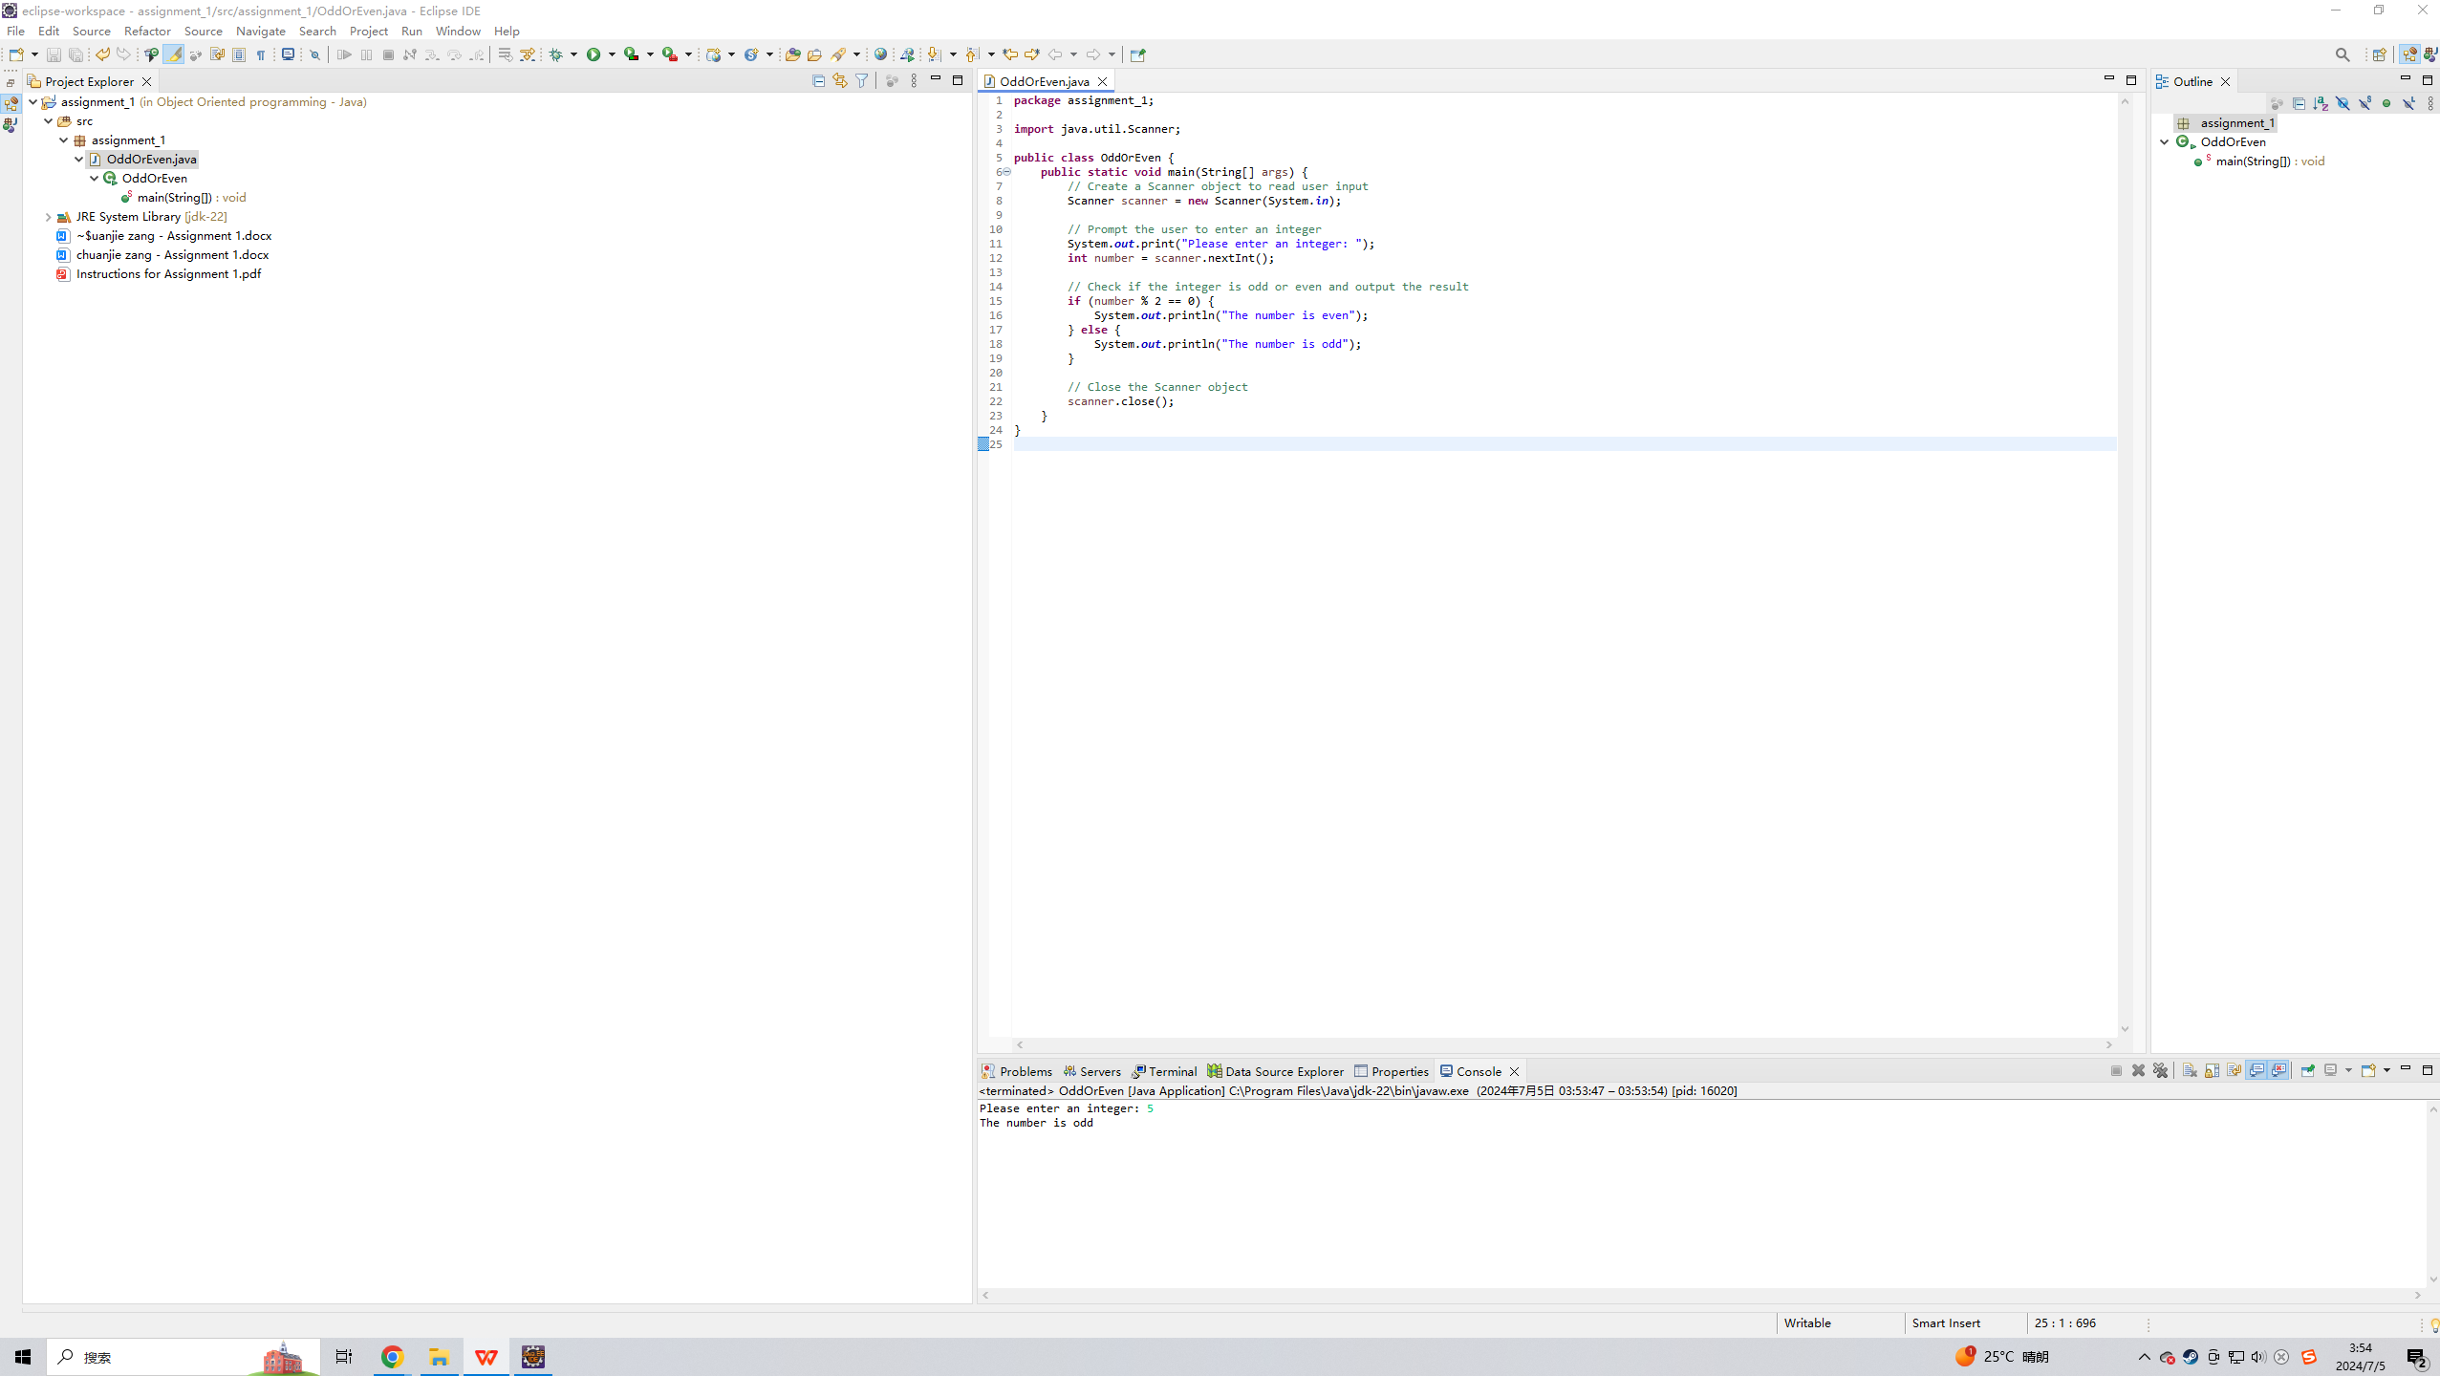

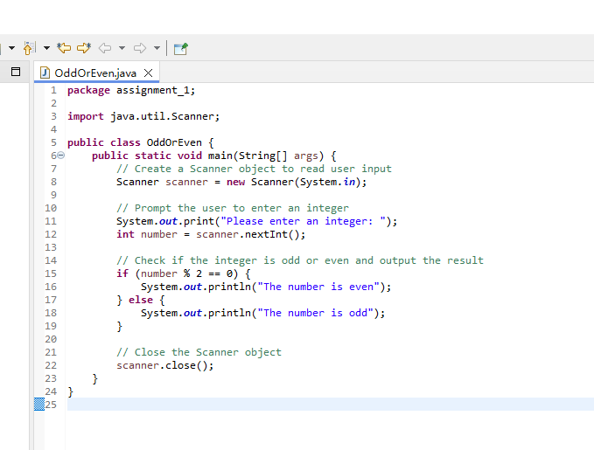

Q2:

Pseudocode.

Start

Output "Please enter a character:"

Reads the input character

Convert the character to an integer equivalent value

Output the character and its integer equivalent value

End

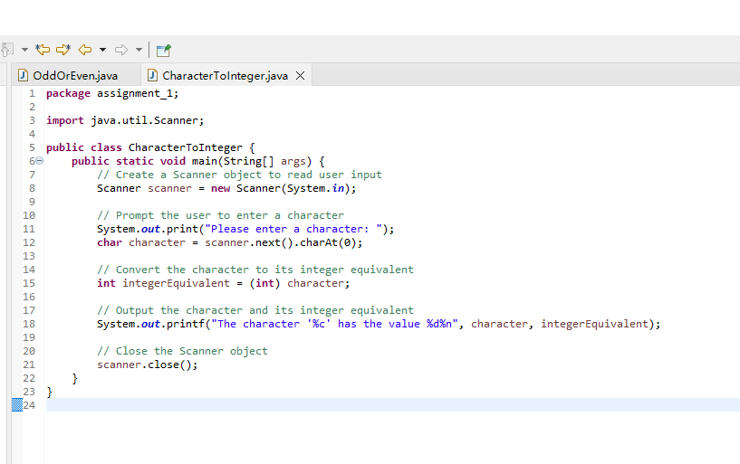

Q2:

Pseudocode.

Getting Started

Create Invoice class

Declare the instance variables: partNumber (String), partDescription (String), quantity (int), pricePerItem (double).

Define the constructor to initialize the instance variables

Define the set and get methods

Define getInvoiceAmount method to calculate and return the invoice amount.

Create InvoiceTest class

Create the Invoice object in the main method

Set and get the value of each instance variable

Output invoice details and invoice amount

End

Translated with DeepL.com (free version)

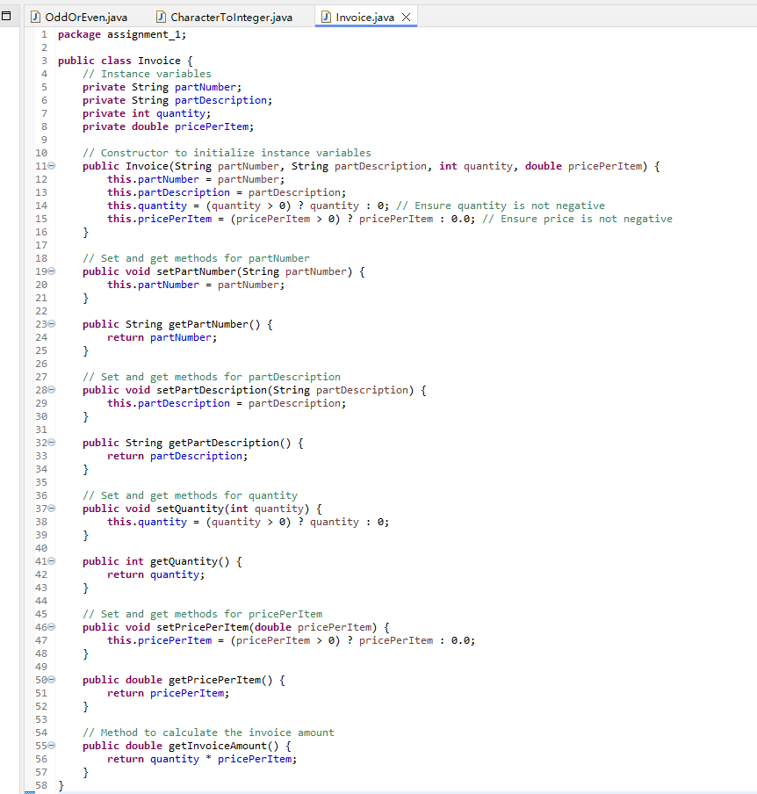

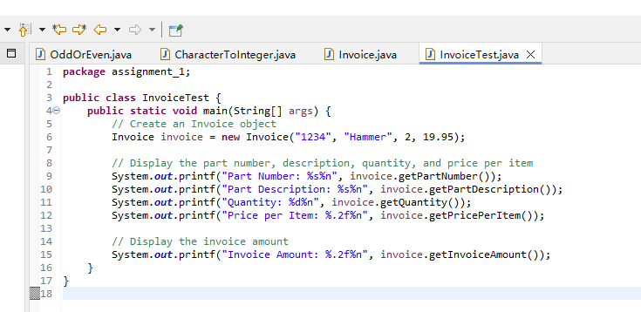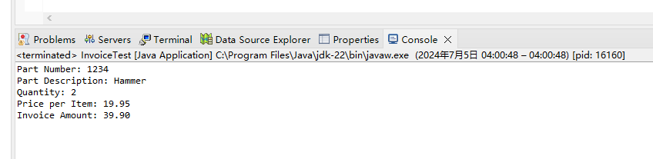

Q4

Pseudocode.

Getting Started

Create the Date class

Declare instance variables: month (int), day (int), year (int).

Define constructor to initialize instance variables

Define set and get methods

Define displayDate method to display date

Create DateTest class

Create Date objects in the main method

Set and get the value of each instance variable

Call the displayDate method to display the date

End

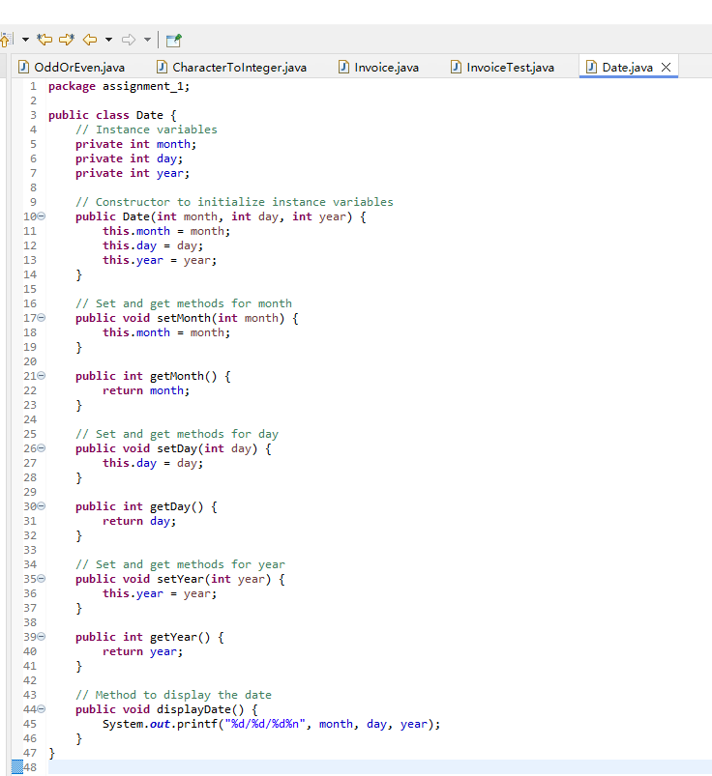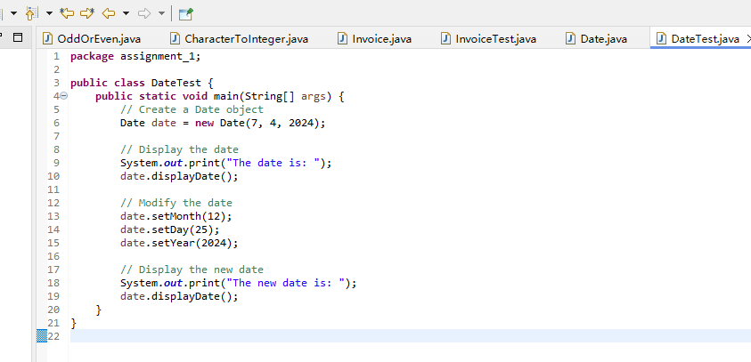

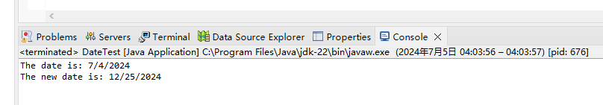

Q5

Pseudocode.

Beginning

Initialize the variables totalMiles and totalGallons to 0.

Initialize the Scanner object to read user inputs

Use a loop to keep getting the miles and gallons entered by the user until the number of gallons entered is -1.

Prompt the user to enter the mileage

Read the miles traveled

Prompt for gallons

Read gallons

If gallons is -1, exit loop

Calculate miles per gallon for current trip

Output miles per gallon for current trip

Add miles and gallons traveled to total miles and gallons traveled

Calculate and output the total miles per gallon traveled

Close the Scanner object

Close

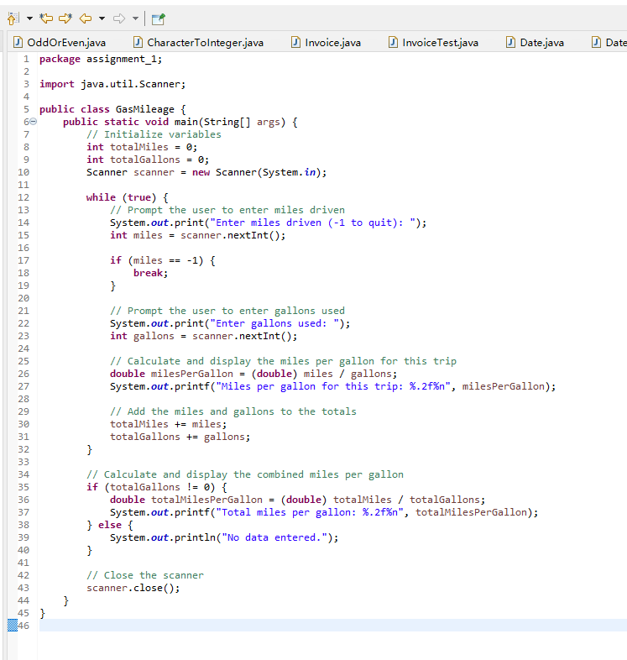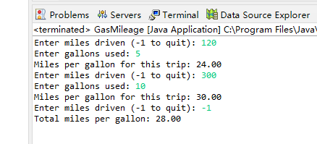

Q6

Pseudocode.

Start

Generating the first pattern using a for loop

Generate the second pattern using a for loop

Generate the third pattern using a for loop

Generate the fourth pattern using a for loop

End

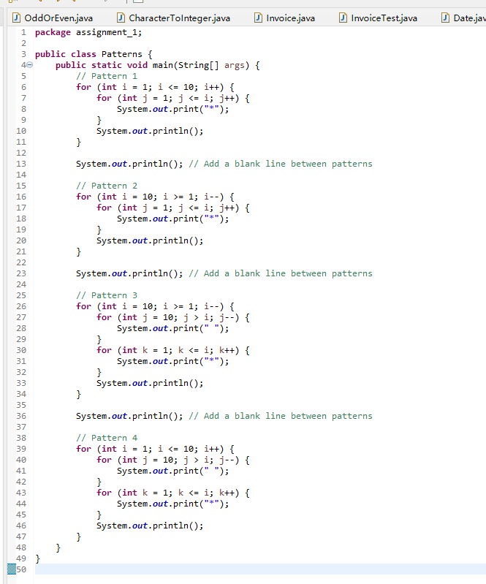

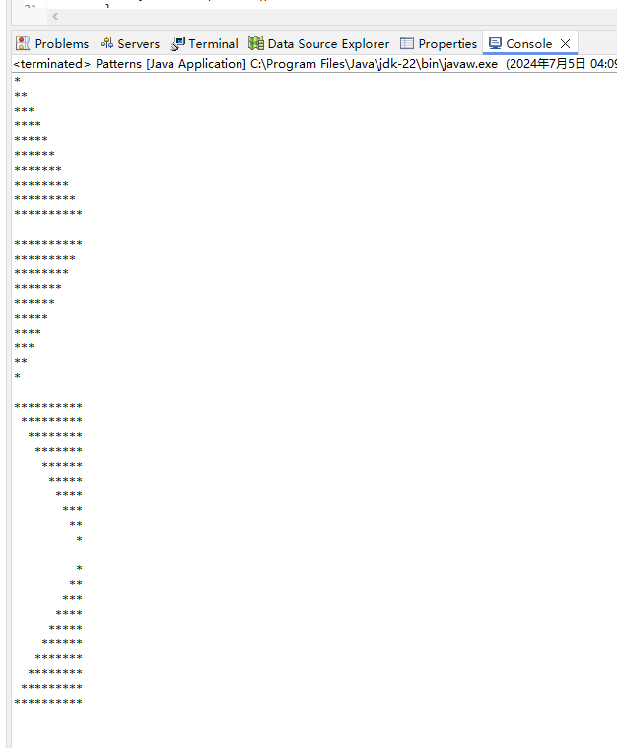

Q7

Pseudocode.

Start

Use two nested for loops to generate the top half of the rhombus

Outer loop from 1 to 5

Inner loop generates spaces

Another inner loop generates an asterisk

Use two nested for loops to generate the bottom half of the diamond.

Outer loop from 4 to 1

Inner loop generates spaces

Another inner loop generates asterisks

End

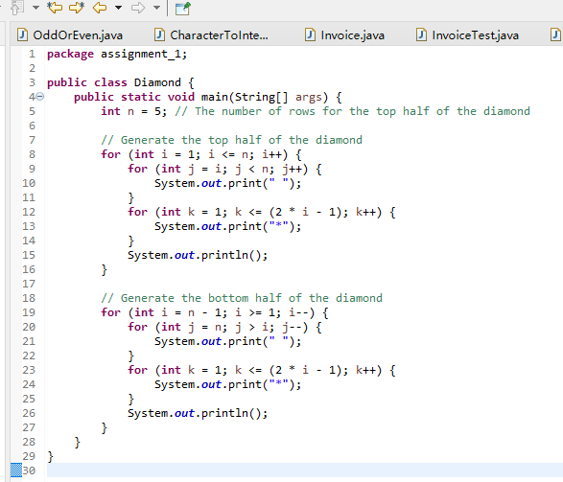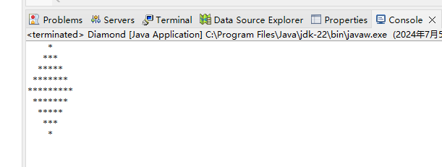

Q8

Pseudocode.

Beginning

Define a method reverseNumber that takes an integer argument and returns its reversed integer.

Initialize the reversed integer to 0.

Using a while loop, reverse the input integer bit by bit and construct the reversed integer.

In the main method

Creates a Scanner object to read user input.

Prompt the user to enter an integer

Read the input integer

Call the reverseNumber method and display the result

Close the Scanner object

End

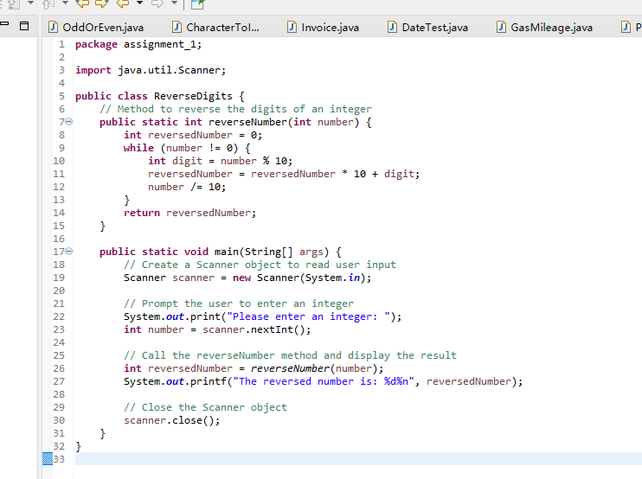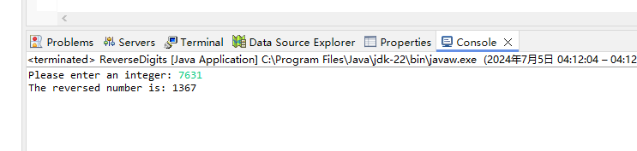

Q9

Pseudocode.

Start

Generate a random integer between 1 and 1000 as the number to guess

Initialize the Scanner object to read the user input.

Initialize a boolean variable guessed to false

When guessed is false

prompts the user to guess a number

Read the number entered by the user

If the number entered by the user is equal to the number to be guessed

Output "Congratulations, you guessed correctly!"

Set guessed to true

Otherwise if the number entered by the user is less than the number to be guessed

Output "Too low. Please try again."

Otherwise

Output "Too high. Please try again."

Close the Scanner object

End

